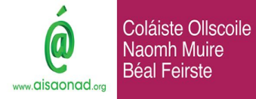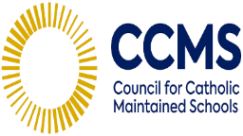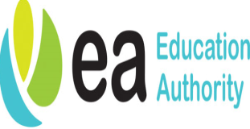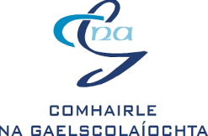

**Achieving Excellence Together**

**Thursday 27 February in Hill of the O’Neill, Dungannon**

**AGENDA**

**9.30am** **Welcome and Introduction**

Gillian McGrath – Director of Education, CCMS

**9.45am** **Introductory Activity: What does High Quality Provision look like?**

Mairéad Mhig Uaid – Education Adviser, An t-Áisaonad

The ESAGS Quadrant

Carousel Activity

**10.25am** **Session One: Child-Centred Provision**

Facilitated by: Gillian McGrath, CCMS

Contributor: Máire Ní Dhónaill, Bunscoil Cholmcille

**10.45am Break**

**11.00am Session Two: High Quality Learning & Teaching**

What does it look like in the immersion setting?

Ensuring the provision of contextualised and meaningful learning experiences

Facilitated by: Mairéad Mhig Uaid

Contributors: Fionnghuala McCotter and Caitríona Nic Sheáin, Scoil an Droichid

**11.45am Session Three: Effective Leadership**

Facilitated by: Shirley McKenna, CCMS

Contributors: Michael Madine and Aisling Uí Ghribín, Gaelscoil Phádraig Naofa

**12.30pm Lunch**

**1.15pm Session Four: A School Connected to its Community**

Facilitated by: Maria Thomasson,Senior Education Support Officer, CnaG

Contributor: Diarmaid Ua Bruadair,Gaelcholáiste Dhoire

**1.40pm Session Five: Monitoring and Evaluating Impact**

Reflection: Leading effective Monitoring and Evaluation – Who? What? Where? When? Why? ....... and How?

Monitoring and evaluation in the Immersion Setting – Our Journey so far

Facilitated by: Máire Nic Giolla Cheara,School Improvement Professional – Sectoral Support Team (EA)

Contributors: Seamus Ó Tuama and Áine Uí Scolláin, Bunscoil Phobal Feirste

**2.30pm Conclusion**

Gillian McGrath, CCMS

What? So what? Now what?

Next Steps

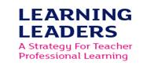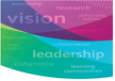**2.45-3.00pm Evaluation and Departure**