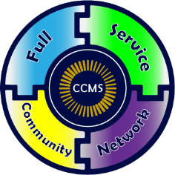
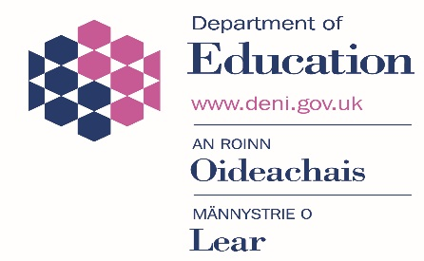
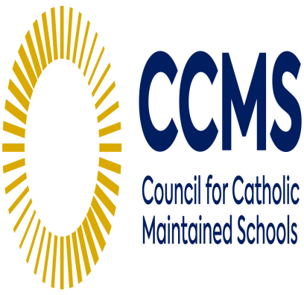

Required: ASAP to 31/03/22

Full Service Community Network @
St Mary's University College
191 Falls Road
Belfast
BT12 6FE

Post: Education and Transition Project Worker (Irish Medium)
Full Time

Ref: T1908/0409

Salary: Incremental scale 26 to 34 (NJC) starting salary will be £23,398

Applicants for the post must, at commencement of appointment, be qualified Irish Medium primary school teachers who:

- Have a high standard of literacy in both spoken and written Irish
- Have at least 6mts experience of Primary teaching within the Irish Medium Sector (which can include teaching practice)

In addition to the above, preference may be given to applicants who, at commencement of appointment:

- Have been directly involved in the delivery of programmes to address educational underachievement
- Have experience of working directly with vulnerable children, young people and families

NB: A Religious Education Certificate is not required for this post.

JOB PROFILE

JOB TITLE: Project Worker - Education and Transition Work

(Irish Medium)

LOCATION: Full Service Community Network, St Mary’s University College Belfast

RESPONSIBLE TO: Project Manager of the FSCN

JOB PURPOSE:

To provide literacy and numeracy support to children, young people and their families in order to improve educational outcomes, reduce barriers to learning and help improve the life chances of disadvantaged children and young people within the Greater Falls and Upper Springfield areas of Belfast.

RESPONSIBILITIES:

Under guidance and instruction from the Project Manager:

- To provide literacy and numeracy support to children in either Irish Medium Naiscoil or Bunscoil settings within the project area.

- To provide transitional support and guidance to children, parents/carers to meet their needs and promote their inclusion in education and within the wider community.

- Plan, prepare, design, deliver and assess appropriate educational interventions to support the learning needs of children and parents/carers.

- To work with children, young people, their families and schools, on a one to one or group basis, to identify needs use a variety of intervention, and carry out assessments in order to achieve positive educational outcomes.

- To work in partnership with parents/carers to empower them and to enable them to achieve better outcomes for their children.

- To work co-operatively with schools, children’s services, health agencies and other community based services, to provide the most effective service for children young people and families.

- To contribute to project development

- To apply safeguarding and child protection procedures

- To be responsible for equipment/resources used in day to day work.

- To be responsible for recording progress and assessment, contributing to report writing and keeping management information in line with GDPR legislation and organisational policy and procedures.

- Any other duties as deemed appropriate.

