Preasráiteas
Press Release

14ú Feabhra 2024

Challenges and Opportunities for Irish-medium Education discussed at Successful Event in Stormont
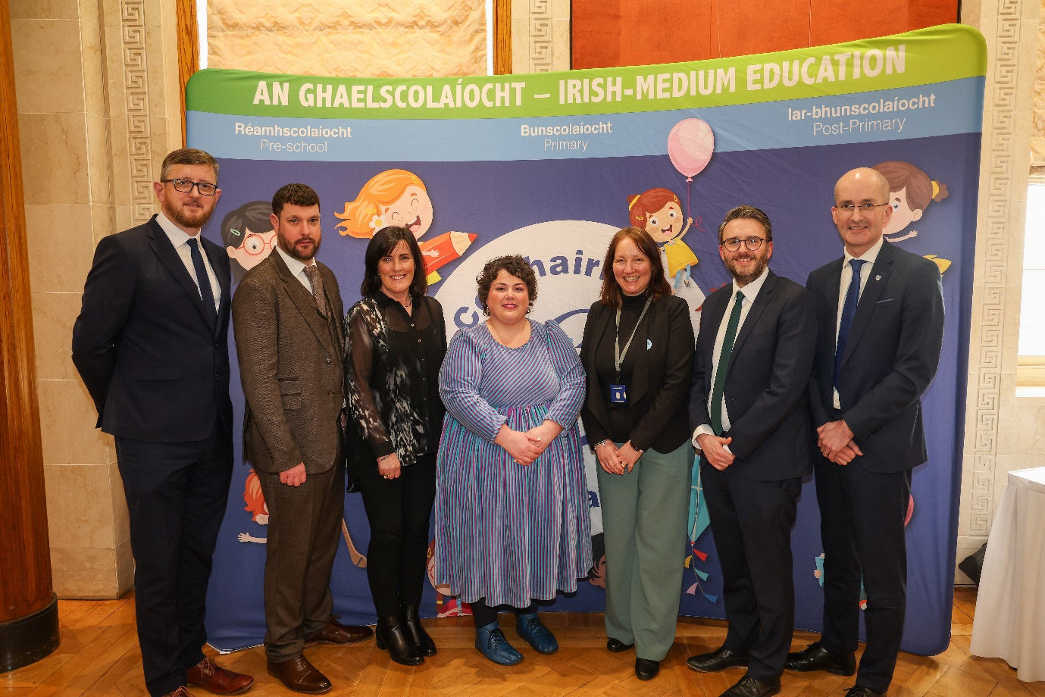
Attending the Comhairle na Gaelscolaíochta (CnaG) / QUB Research Symposium on 6 February, l-r: Seosamh Ó Coinne, Chairperson of CnaG; Ciarán Catney, Senior Officer 'A Fair Start' CnaG; Joyce Logue, 'A Fair Start' panel member; Maria Thomasson, CEO, CnaG: Shirley Sweeney, Department of Education; Nick Mathison, MLA, main sponsor of the event and Professor Noel Purdy, University of Stranmillis College, Chairperson of 'A Fair Start’ panel.

A Research Symposium was held on 6th February in The Long Gallery in Stormont, to discuss a Queen's University report entitled Fair? Shared? Supported? Examining the Expectations and Realities for Irish-medium practitioners.

The research was commissioned by Comhairle na Gaelscolaíochta, and the event was attended by practitioners from the Irish-medium sector; staff of local & national educational organisations and local political representatives from various parties. Nick Mathison, MLA, was the main sponsor of the event with the support of other Assembly parties.

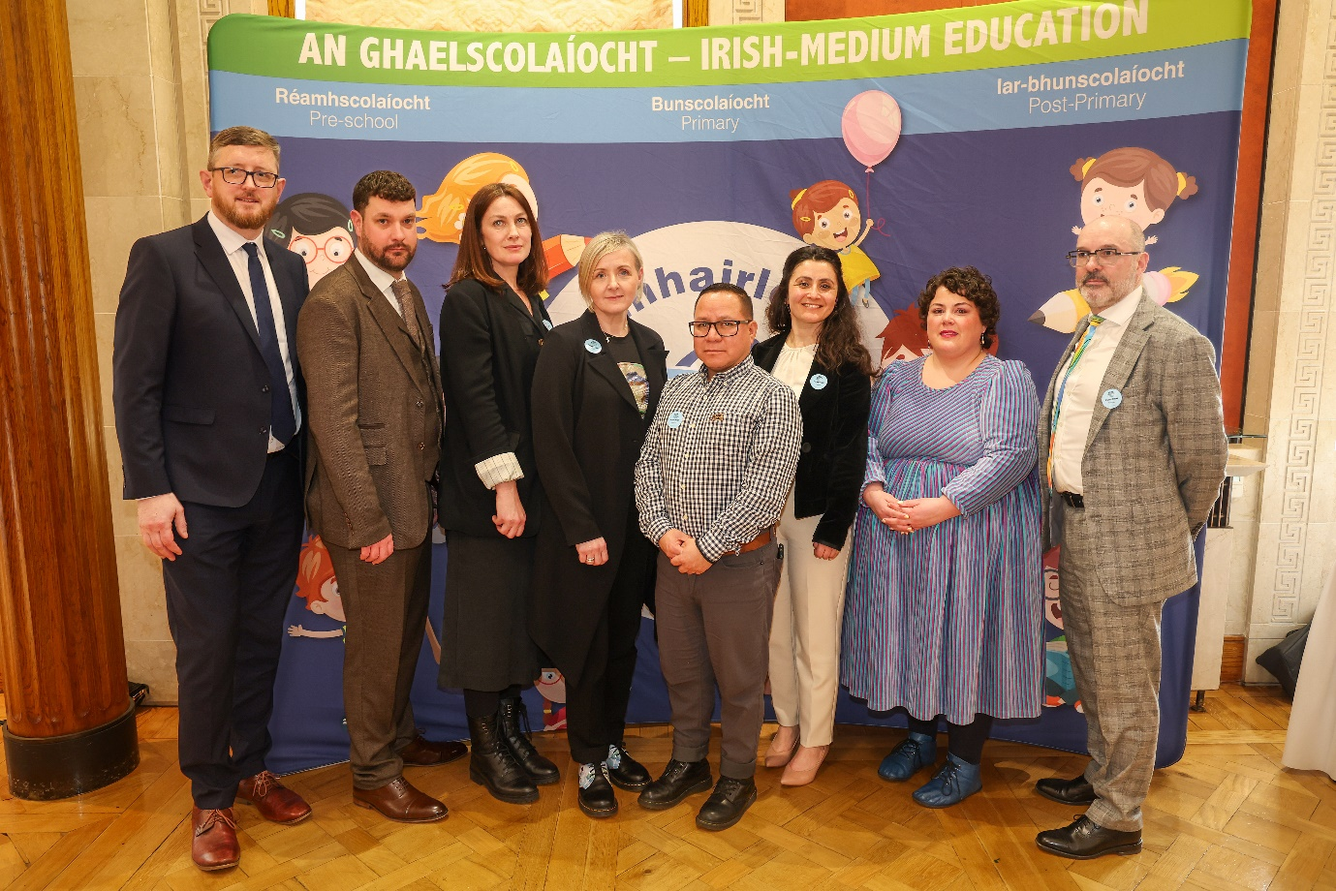
In attendance at the Research Symposium in Stormont this week, from left; Seosamh Ó Coinne, Chairperson of CnaG; Ciarán Catney, Senior Officer A Fair Start, CnaG; Dr Mel Engman, Dr Aisling O'Boyle, Dr Yecid Ortega and Dr Sultan Turkan, QUB; Maria Thomasson, CEO of CnaG and Dr Daniel Muijs, QUB.

In the context of the ongoing shortage of teachers in the Irish-medium sector, as well as issues relating to recruitment and retention, the QUB / CnaG report focuses on those additional competencies and the significant challenges facing Irish-medium practitioners as well as recommendations to address these challenges.

In addition to the QUB research team, Professor Noel Purdy, Stranmillis University College, and panel chair of the A Fair Start report, spoke of the link between the content of the A Fair Start and the QUB report; A Fair Start analysed underachievement in the local educational system. Gaelscoil an Lonnáin Principal, Ciarán Mac Ailín, spoke of his day-to-day experience in the sector and CnaG officials spoke of the major issue of teacher supply in the Irish-medium education sector as well as the lack of facilities, assessment tools and TPL opportunities.

Commenting on the success of this significant event, Maria Thomasson, CEO of CnaG said:
'I am hopeful that now that the challenges and solutions associated with particular aspects of Irish-medium education have been discussed in public and in front of our local representatives, we will see practical actions implemented shortly, which will benefit the whole IM sector. We have requested meetings with the new Minister for Education and the new Minister for the Economy to discuss these important issues. It is time that the appropriate investment is made available to the Irish-medium education sector so that these challenges can be addressed on a strategic basis. ’

An executive summary of the Research Report and the full text can be found here:
https://www.qub.ac.uk/research-centres/CentreforLanguageEducationResearch/filestore/Fair%20Shared%20Supported-Expectations%20and%20realities%20for%20IM%20practitioners%20Research%20Report%20ACC.pdf

https://www.qub.ac.uk/research-centres/CentreforLanguageEducationResearch/filestore/Fair%20Shared%20Supported%20Executive%20Summary%20and%20Action%20Plan%202023.pdf

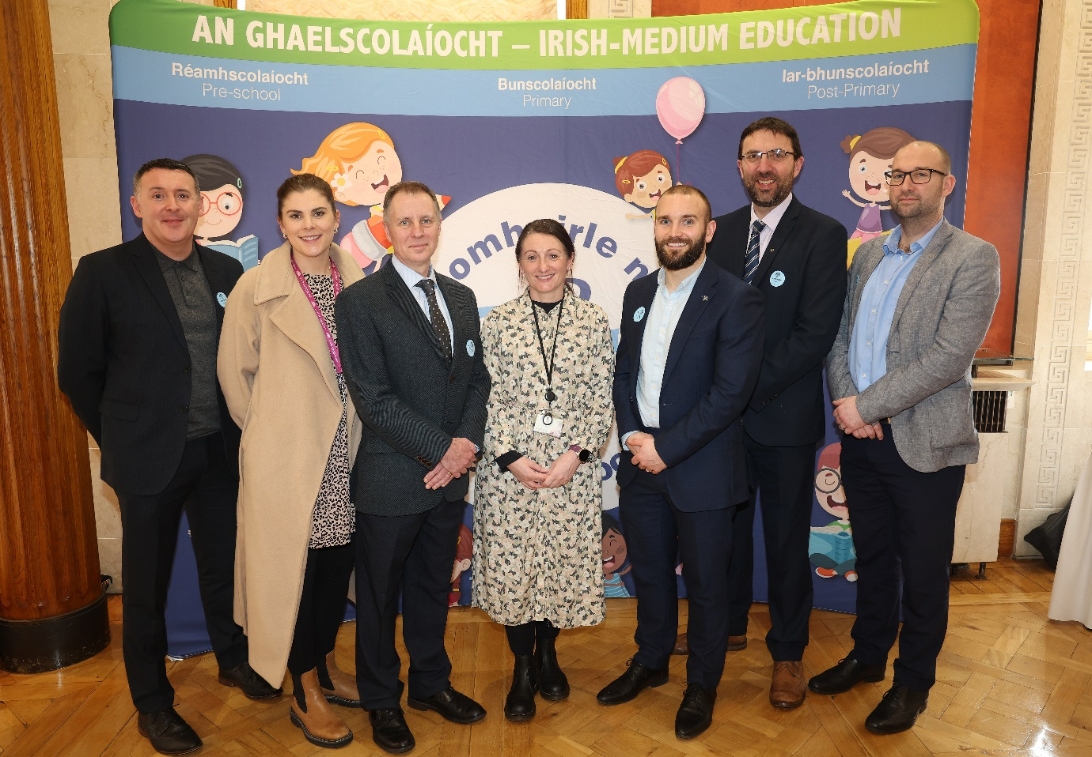

Practitioners from the IM sector who attended the Research Symposium

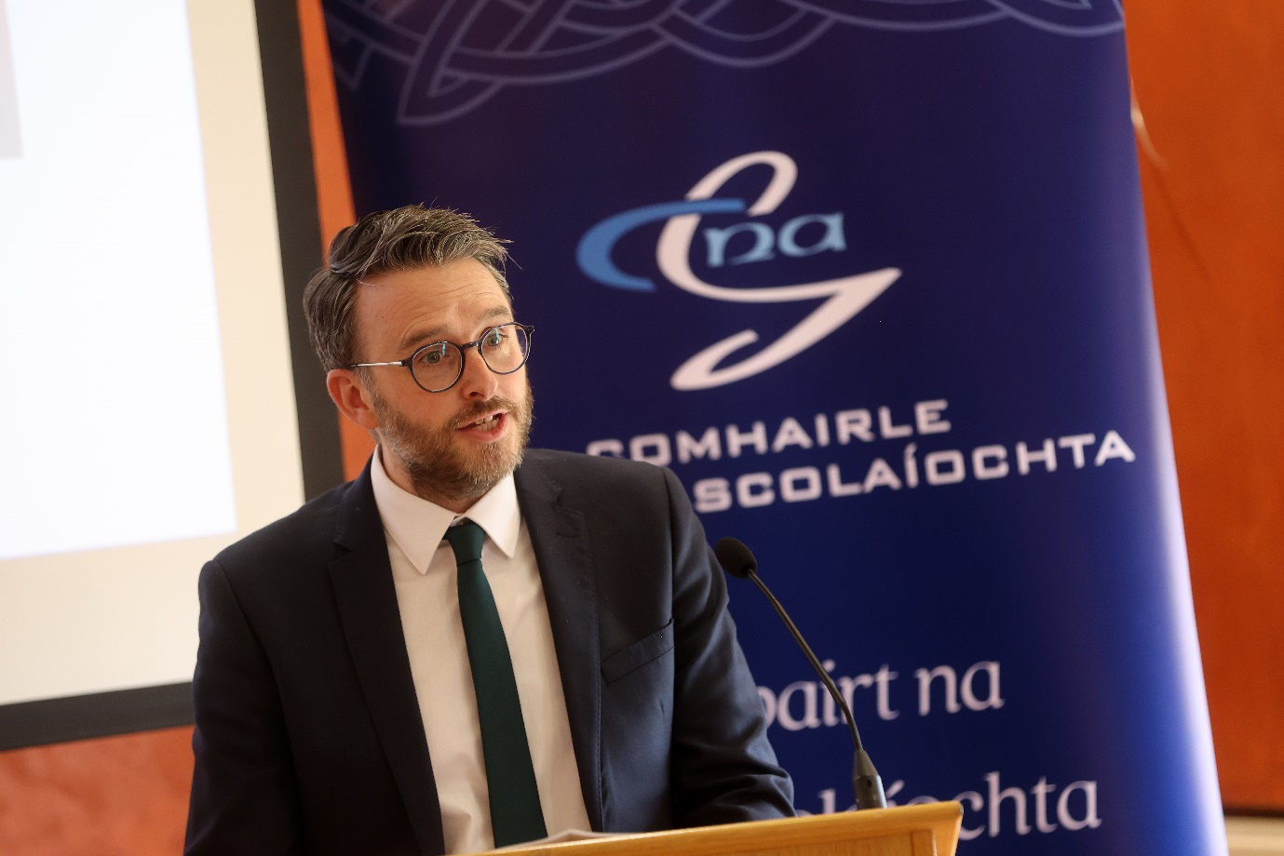
Nick Mathison, MLA, welcoming delegates to the Symposium in Stormont’s Long Gallery, 6/2/24
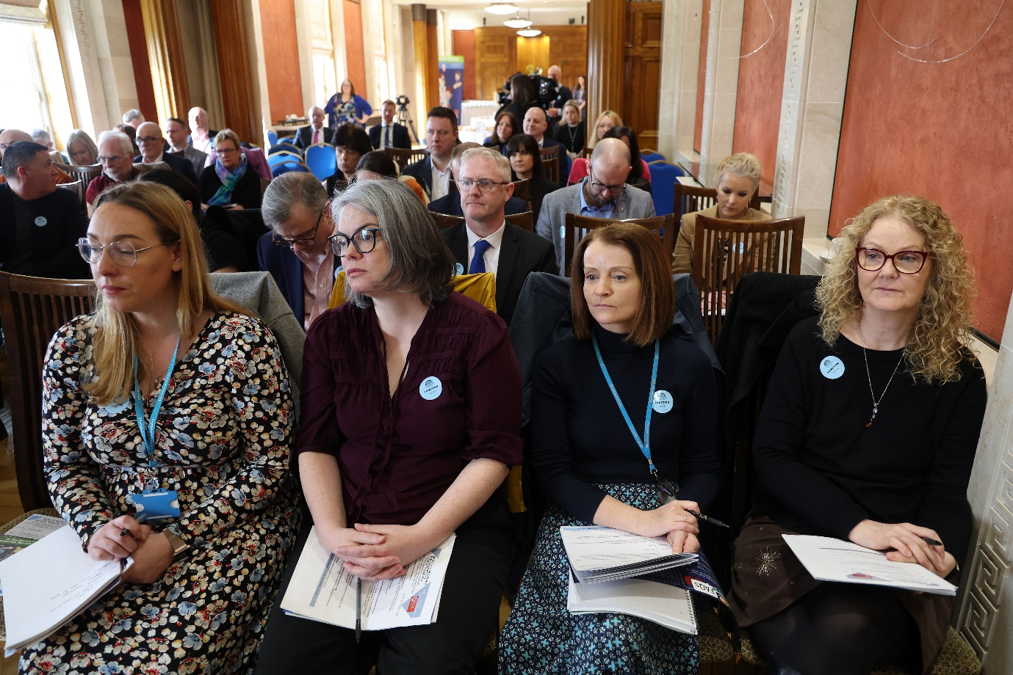
Delegates attending the CnaG / QUB Research Symposium in Stormont, 6th February.
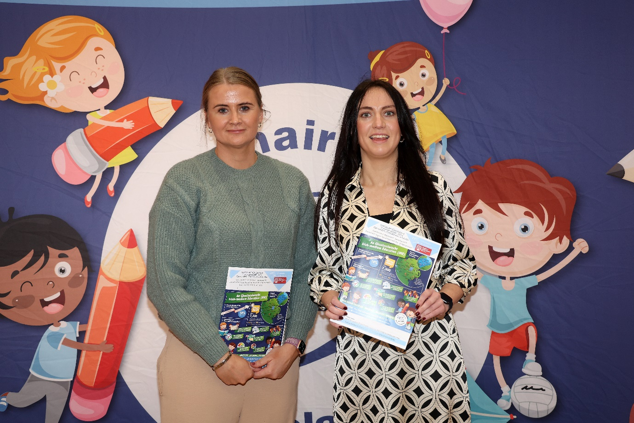
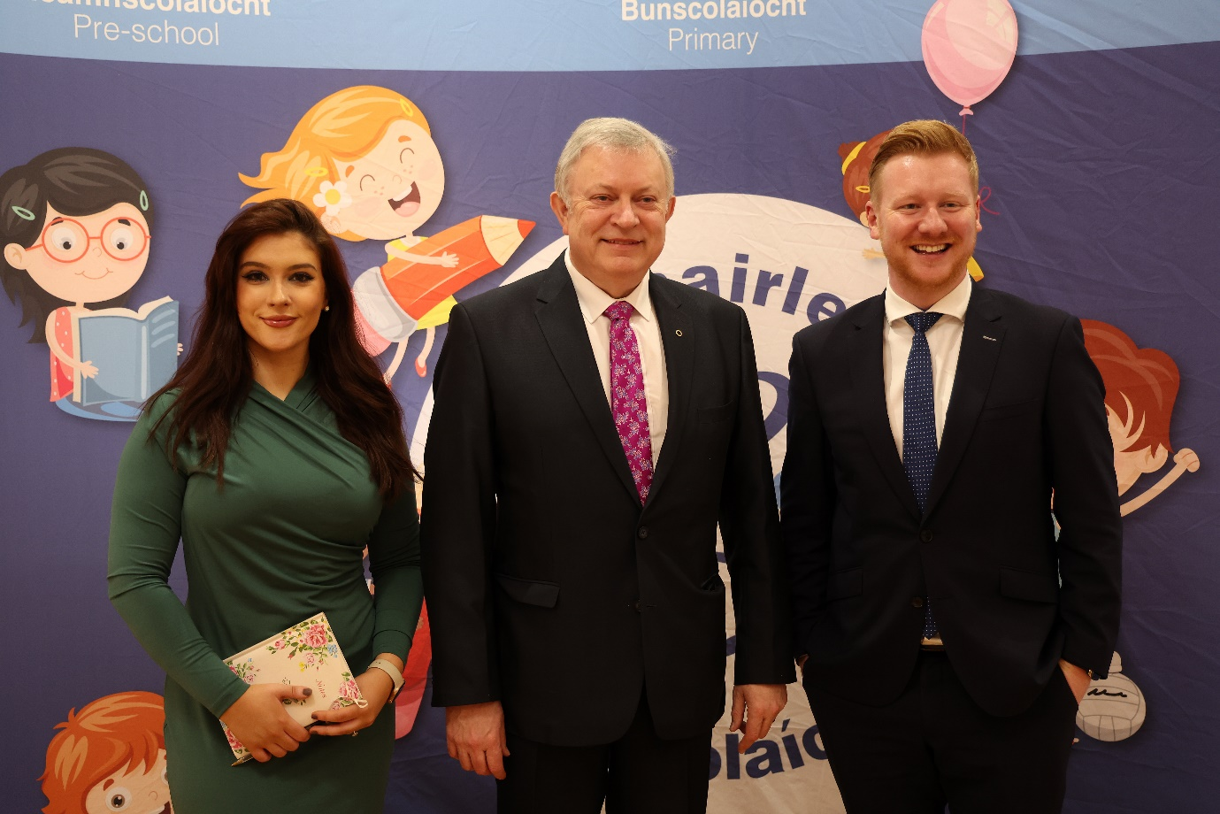
Representatives of local political parties in attendance at the QUB/ CnaG research.

